# **Design Phase**

**2.1 Frontend Designs**

**-> Class Based UML Diagram**

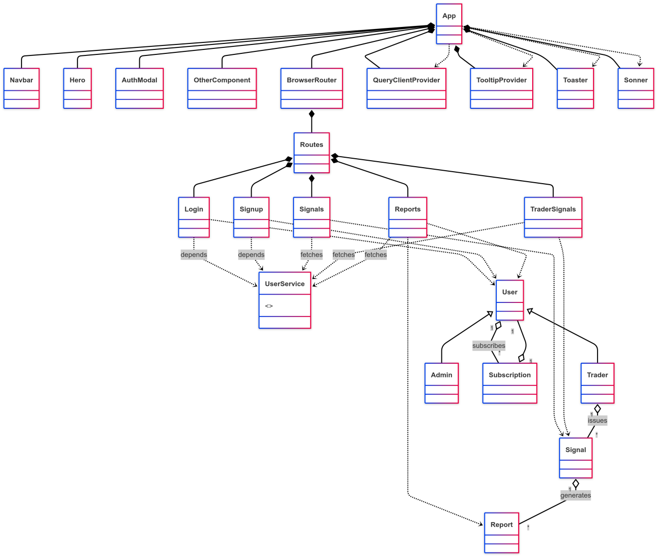

**-> DFD LEVEL 0**

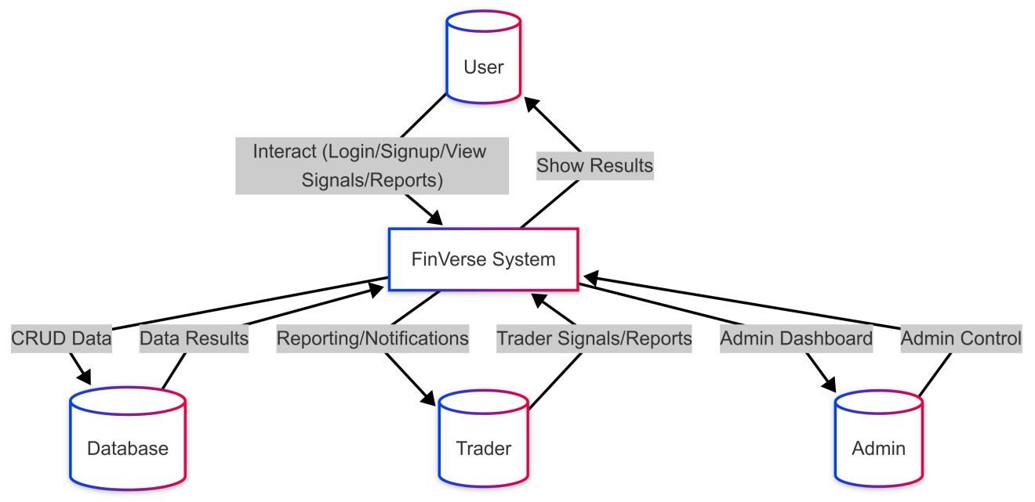

**-> DFD LEVEL 1:**

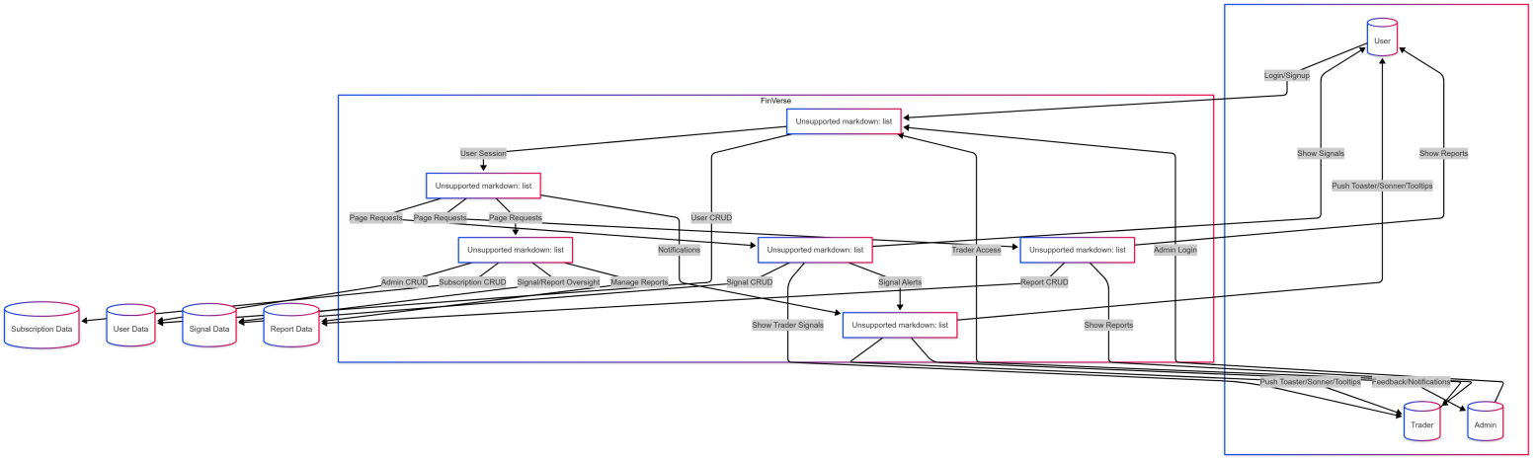

**-> DFD LEVEL 2:**

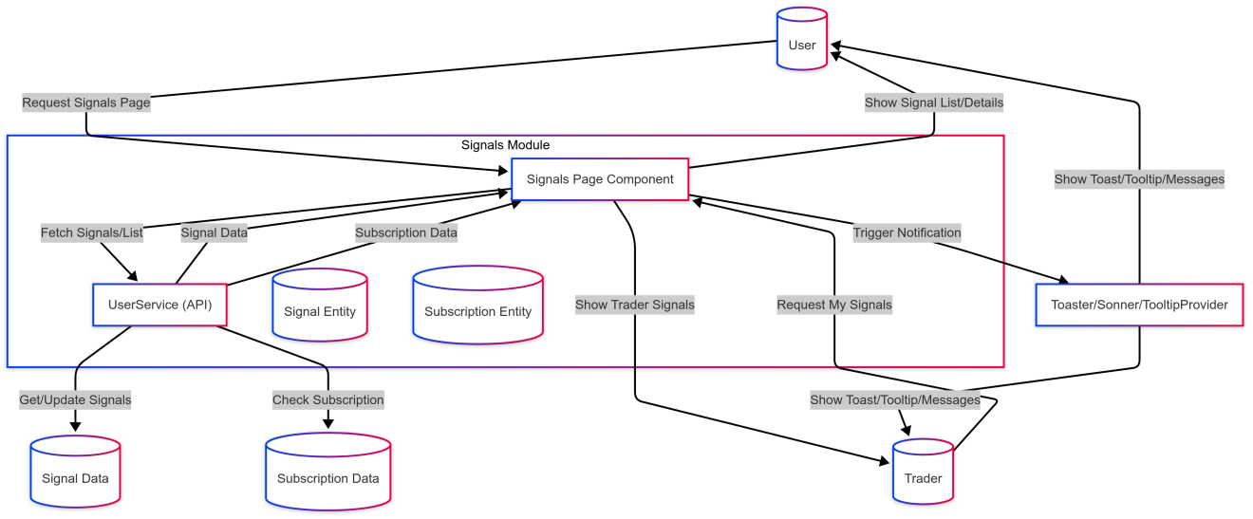

**-> ER DIAGRAM:**

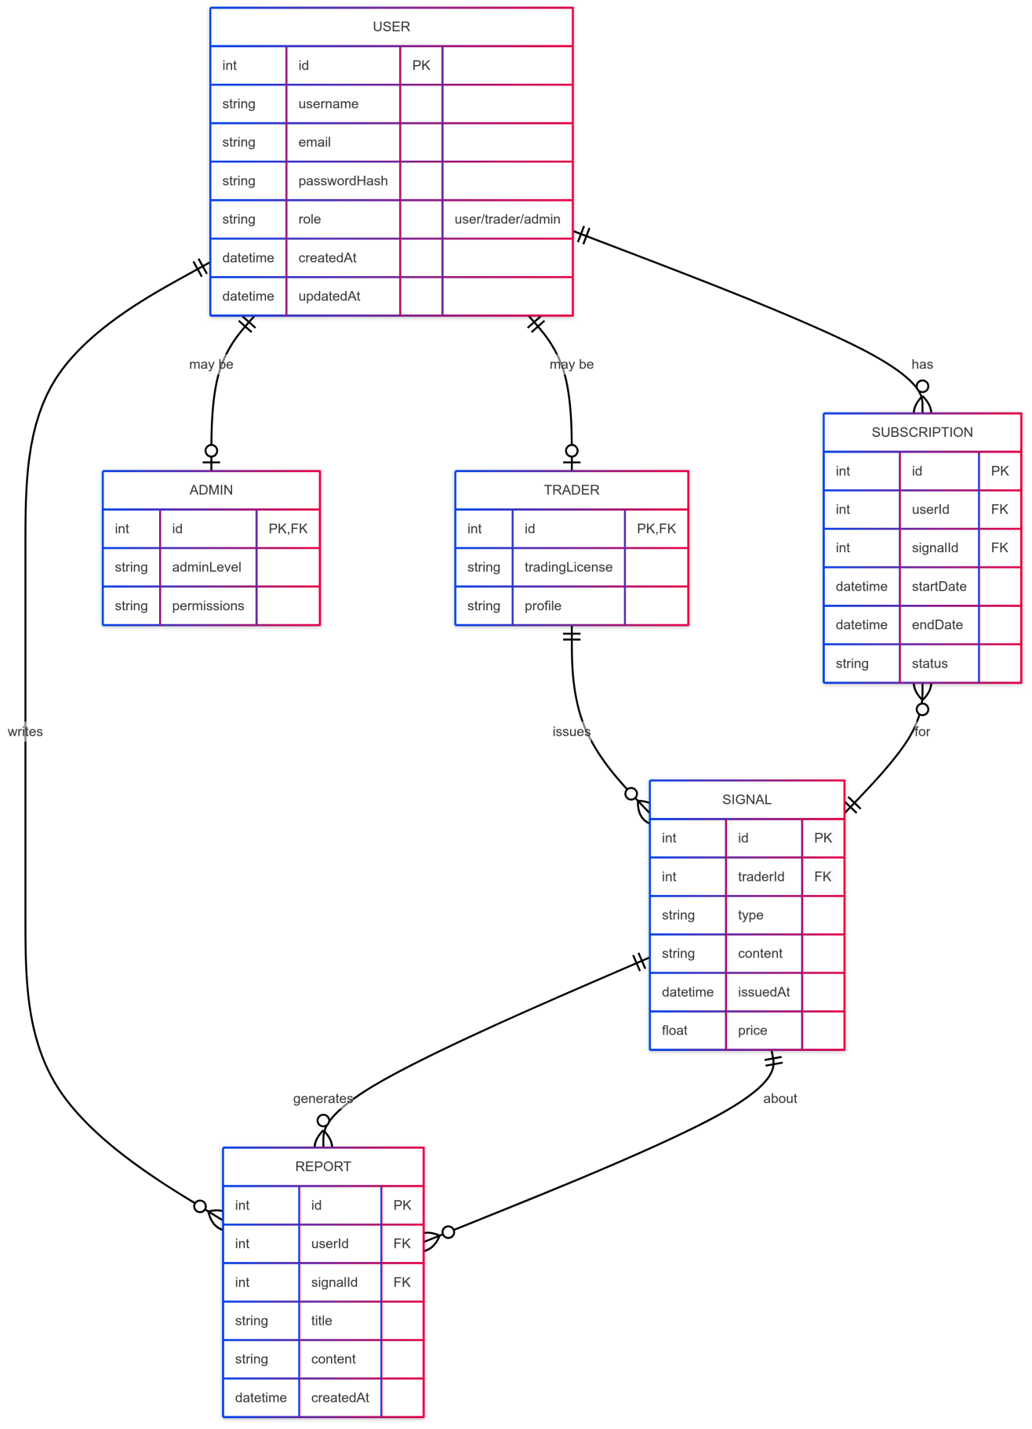

**-> PROCESS FLOW DIAGRAM:**

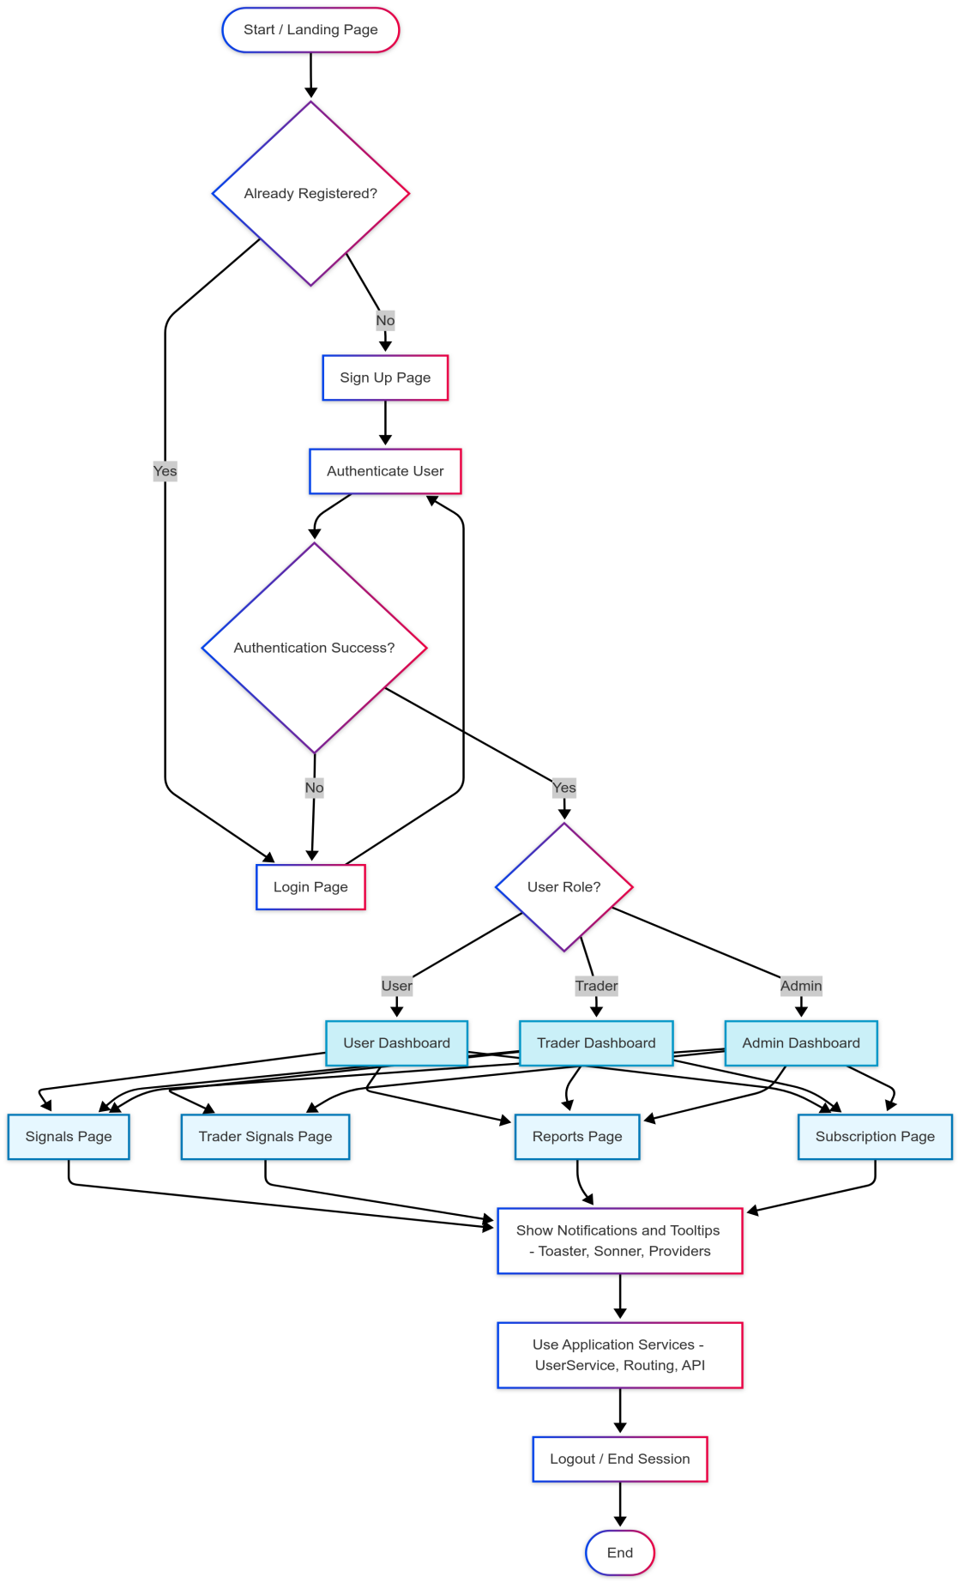

# **3. Backend Design**

**-> UML Class Based Diagram**

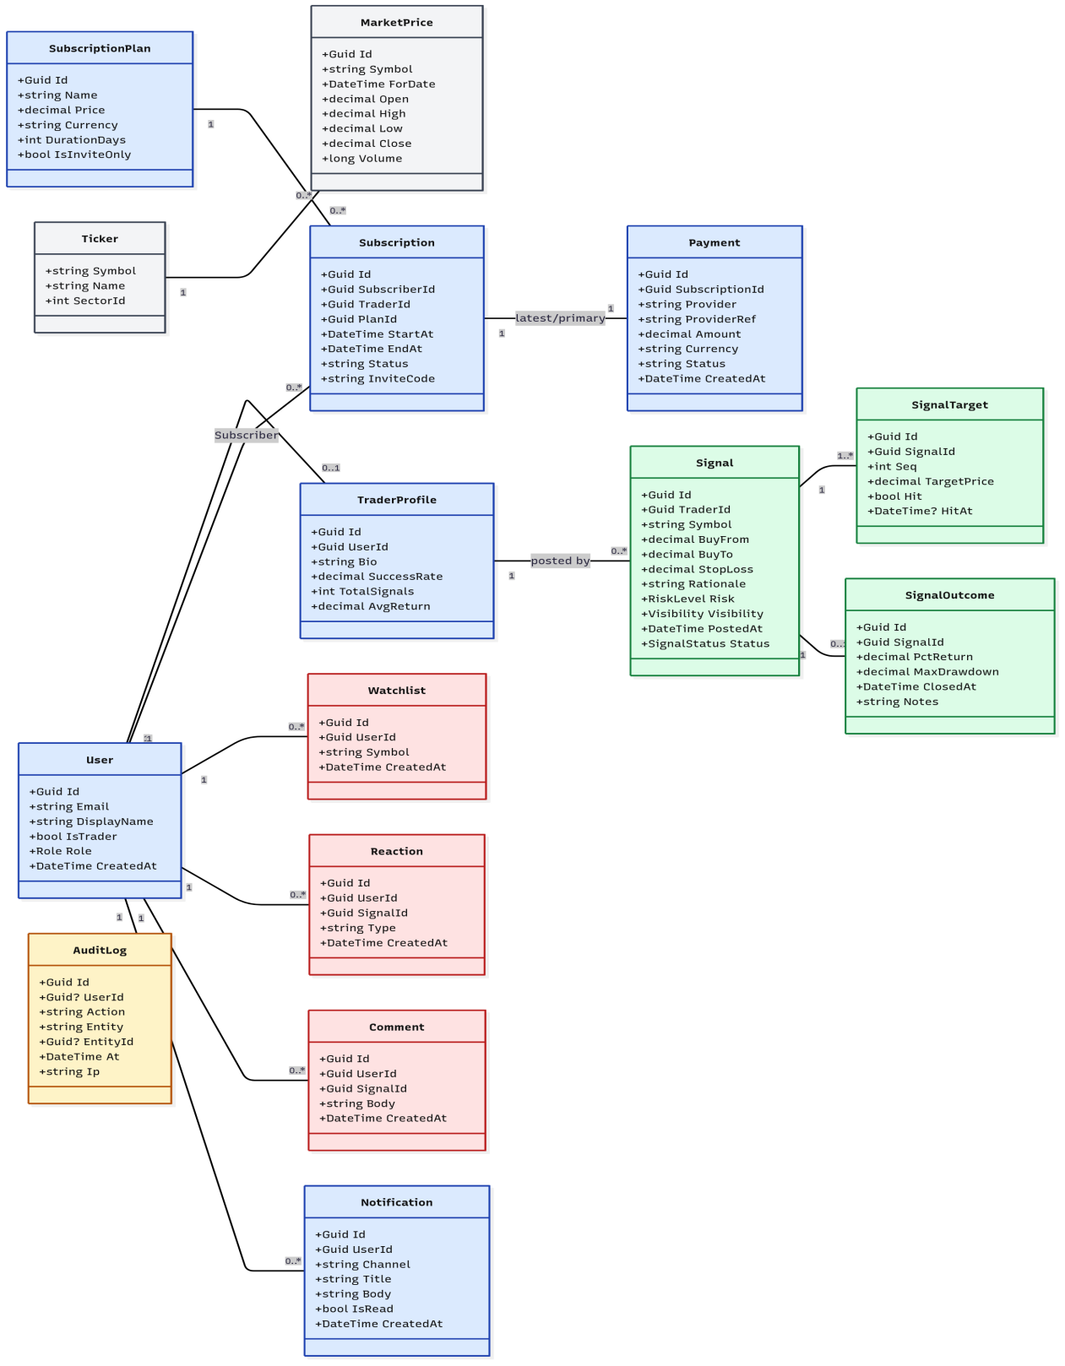

**-> DFD Level 0**

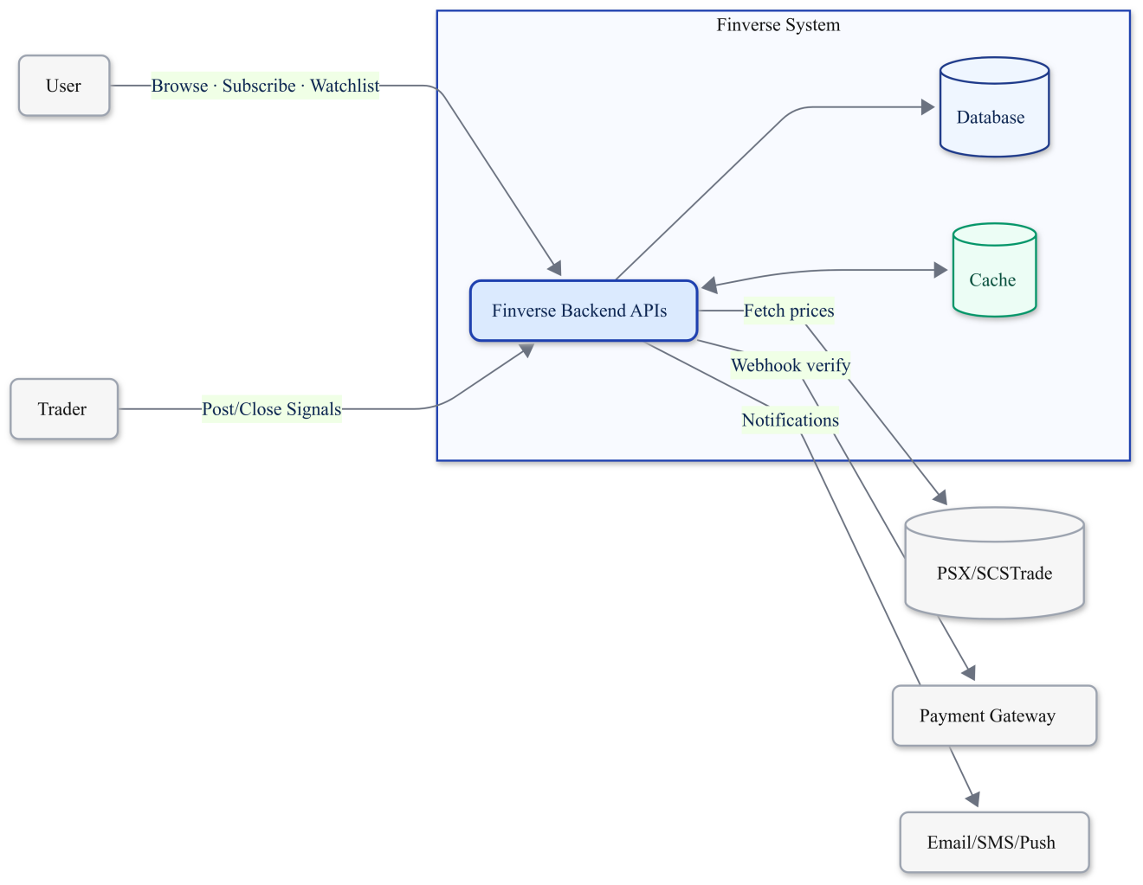

**-> DFD LEVEL 1**

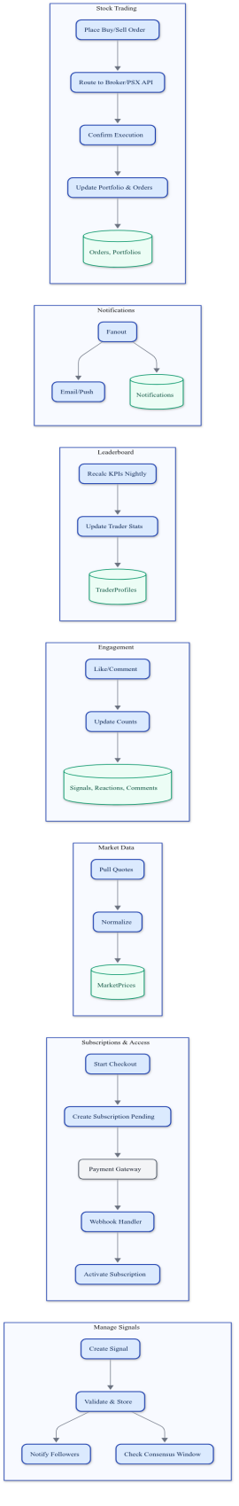

**-> ER DIAGRAM:**

